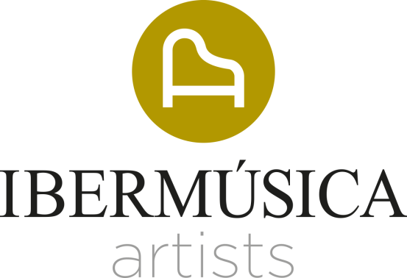

TRULS MØRK
CELLO
Truls Mørk’s compelling performances, combining fierce intensity, integrity and grace, have established him as one of the pre-eminent cellists of our time.
Truls Mørk is a celebrated artist who performs with the most distinguished orchestras including the Orchestre de Paris, Berliner Philharmoniker, Wiener Philharmoniker, Concertgebouworkest, Münchner Philharmoniker, Philharmonia and London Philharmonic orchestras and Gewandhausorchester Leipzig. In North America he has appeared with New York Philharmonic, The Philadelphia and Cleveland orchestras, Boston Symphony Orchestra and Los Angeles Philharmonic. Conductor collaborations include Esa-Pekka Salonen, David Zinman, Manfred Honeck, Gustavo Dudamel, Sir Simon Rattle, Kent Nagano, Yannick Nézet-Séguin and Christoph Eschenbach, amongst others.
The 2022/23 sees engagements with New York Philharmonic and The Cleveland orchestras under Klaus Mäkelä, Oslo Philharmonic Orchestra with Stanislav Kochanovsky, Philharmonia Orchestra conducted by Tabitha Bergund, on tour with Die Deutsche Kammerphilharmonie Bremen under Elim Chan which will include the Vienna’s Musikverein, Rundfunk-Sinfonieorchester Berlin with Vladimir Jurowski, concerts in Spain with the Royal Philharmonic and Vasily Petrenko. Truls Mørk will be Artist in Residence at the 2022 Dvořák Festival, where he will perform with the Münchner Philharmoniker under Myung-Whun Chung.
A great champion of contemporary music, Truls Mørk has given in excess of 30 premieres. In the 2019/20 season, he premiered Victoria Borisova-Ollas’ cello concerto Oh Giselle, Remember Me, commissioned by the Swedish Radio Symphony Orchestra – where he was Artist in Residence, as well as Bergen Philharmonic Orchestra, Gothenburg Symphony, and Royal Liverpool Philharmonic Orchestra. He has also given highly successful performances of Esa-Pekka Salonen’s Cello Concerto, conducted by the composer at the Royal Festival Hall, Lincoln Center and the Festival d’Aix en Provence. In collaboration with Klaus Mäkelä, he performed the Salonen Cello Concerto with Orchestre Philharmonique de Radio France and Oslo Philharmonic Orchestra. Other commissions include Rautavaara’s Towards the Horizon with the BBC Symphony Orchestra and John Storgårds, Pavel Haas’ Cello Concerto with Wiener Philharmoniker and Jonathan Nott, Krzysztof Penderecki's Concerto for Three Cellos with NHK Symphony Orchestra and Charles Dutoit, Hafliði Hallgrímsson's Cello Concerto, co-commissioned by Oslo Philharmonic, Iceland Symphony and Scottish Chamber orchestras.
With an impressive recording output, Truls Mørk has recorded many of the great cello concertos for labels such as Virgin Classics, EMI, Deutsche Grammophon, Ondine, Arte Nova and Chandos many of which have won international awards including Gramophone, Grammy, Midem and ECHO Klassik awards. These include Dvořák’s Concerto (Mariss Jansons/Oslo Philharmonic), Britten's Cello Symphony and Elgar's Concerto (Sir Simon Rattle/CBSO), Miaskovsky Concerto and Prokofiev's Sinfonia Concertante (Paavo Järvi/CBSO), Dutilleux (Myung-Whun Chung/Orchestre Philharmonique de Radio France), CPE Bach (Bernard Labadie/Les Violons du Roy), Haydn's Concertos (Iona Brown/Norwegian Chamber Orchestra), Rautavaara’s Towards the Horizon (John Storgårds/Helsinki Philharmonic Orchestra) as well as the complete Bach Cello Suites and Britten Cello Suites. Later recordings include Shostakovich’s Concertos with Oslo Philharmonic Orchestra/Vasily Petrenko, works for cello and orchestra by Massenet with the Orchestre de la Suisse Romande/Neeme Järvi and the Saint-Saëns Concertos together with the Bergen Philharmonic Orchestra/Neeme Järvi. His most recent recording features the sonatas by Bridge, Britten and Debussy performed with Håvard Gimse and released on Alpha Classics.
Initially taught by his father, Truls Mørk continued his studies with Frans Helmerson, Heinrich Schiff and Natalia Schakowskaya. In his early career, he won a number of competitions such as the Moscow Tchaikovsky Competition (1982), Cassado Cello Competition in Florence (1983), the Unesco Prize at the European Radio-Union competition in Bratislava (1983) and the Naumberg Competition in New York (1986).
Season 2022.23

